Wren Todd
Prof. Xiaoxi Zhang
DATA 5100-01
10-7-2026
Seattle v. West Lafayette Precipitation 2018-2022
As a student in the MSDS program at Seattle University, when posed with the question of comparing two cities precipitation levels, it felt right to compare Seattle with my undergraduate home of West Lafayette, Indiana. The problem at hand is determining which of the cities that I have lived in has a greater level of precipitation. The data used in this analysis came from the NOAA site, checking daily summaries from January 1st, 2018 to December 31st, 2022.
After cleaning the data, I analyzed it by comparing the cities in a variety of ways. Initially, I checked the two cities by plotting the daily rain in inches side by side, but this only created a difficult to read chart. To further assess, I checked the descriptive statistics including the mean daily average precipitation in inches. After determining that West Lafayette had a higher average daily rainfall (fig. 1), I changed tact to see two different views of the data.
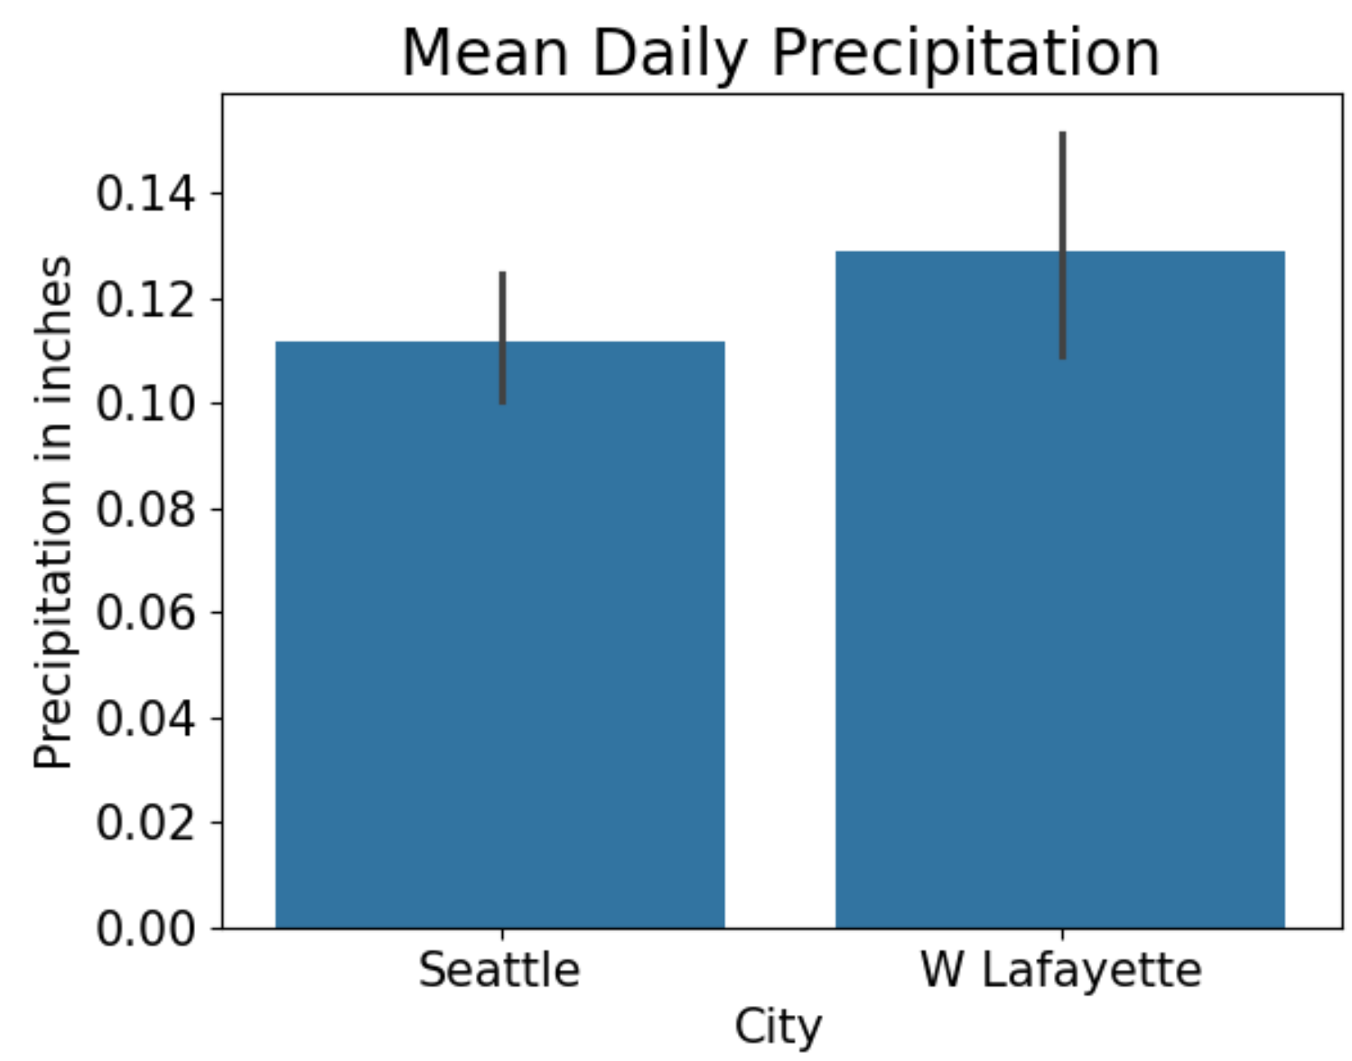
Figure 1
First, I checked the rainfall monthly to see that the rain typically occurred in the winter for Seattle, but in the summer for West Lafayette. West Lafayette also was concentrated in fewer months, leading me to believe that there is heavier rainfall in West Lafayette across fewer days. To verify this last claim, I created a new column to check the number of days that had any precipitation. In doing so, I was able to compare that Seattle consisted of more days in a year with rain, which means that it rains less heavily (fig. 2).
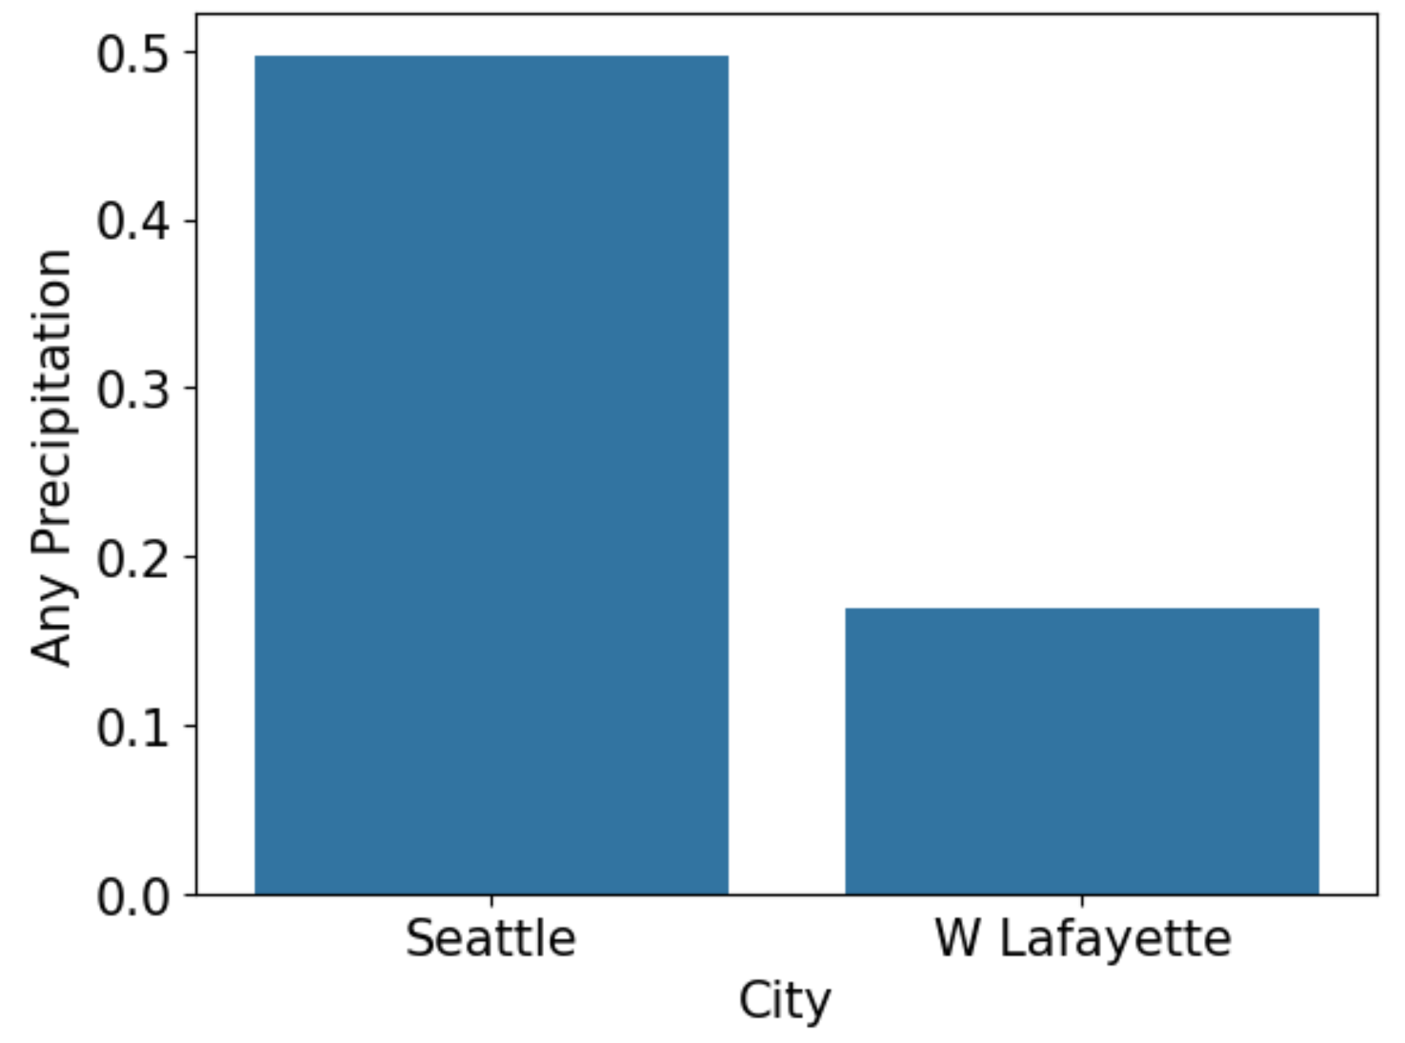
Figure 2
Despite doing this analysis, there are some limitations in the data that should be noted. Firstly, the number of days that were missing values in West Lafayette far exceeded that of Seattle, which creates a concern about the validity of imputed values. Secondly, while I am checking the cities of universities, the Seattle location is not centered on the university as the West Lafayette one is, but on an airport, which may have slight variations from Seattle Universities actual precipitation levels. Lastly, we did not preemptively define what constitutes as the rainier city, whether that is the city with the most rainfall or the city with the most rainy days. Due to these limitations, this analysis can reviewed, but more analysis should be done adjusting for this.
As we can see from the above, Seattle is the rainier city when considering the number of days in the year with rain, but actually has less overall precipitation per day on average during the years of 2018-2022. In light of this, I know that the rain experienced in my new home of Seattle is both lighter, but more frequent than that of West Lafayette.

